

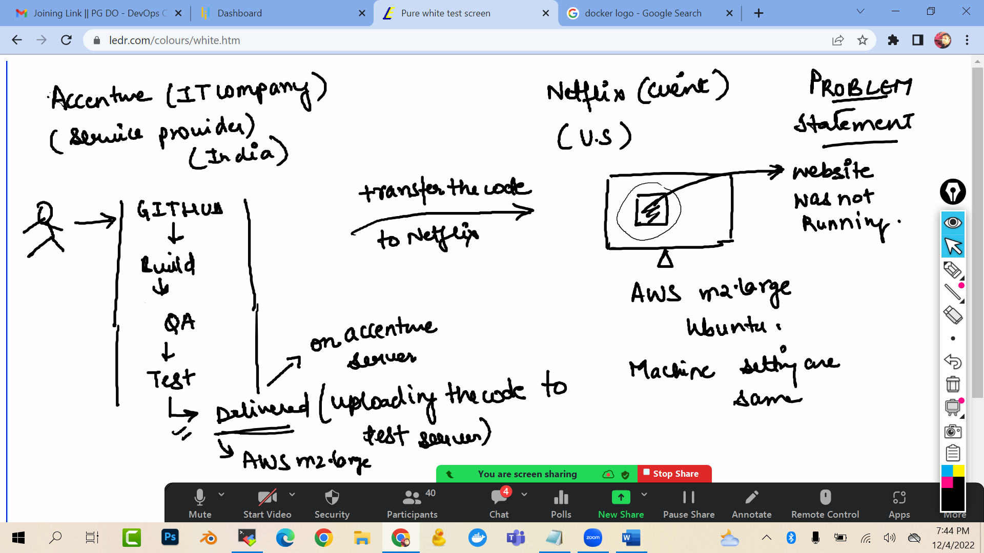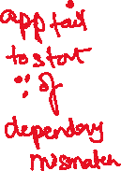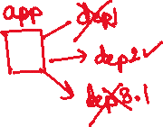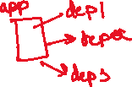

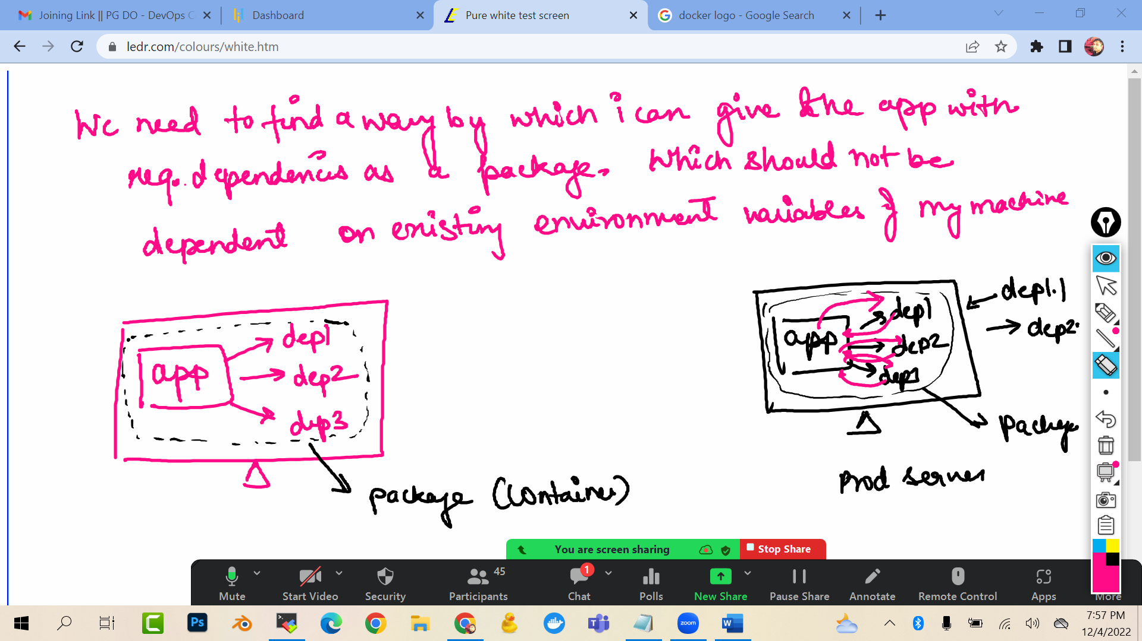

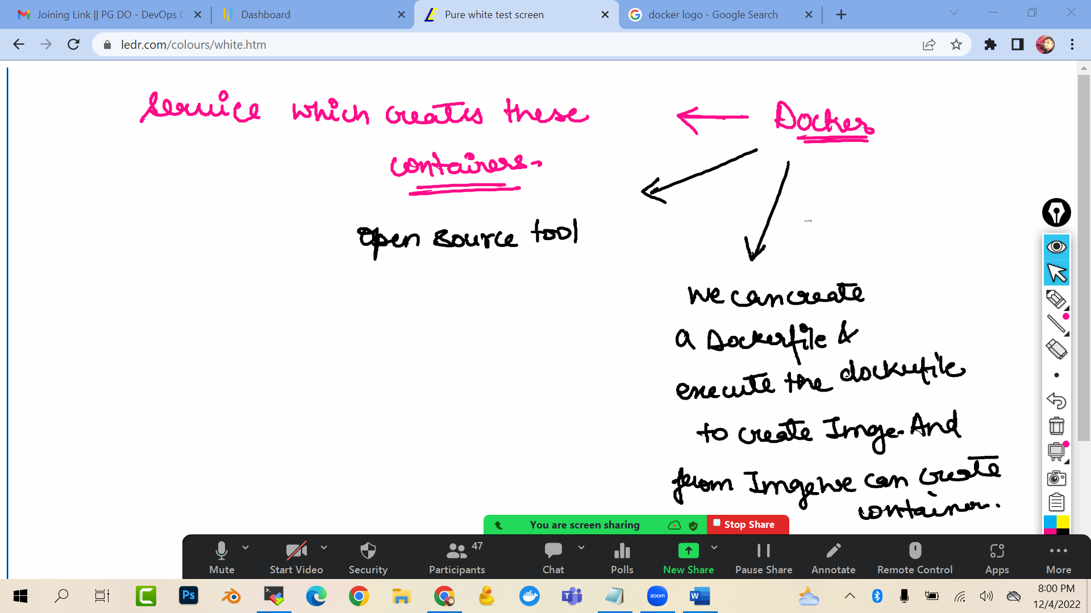

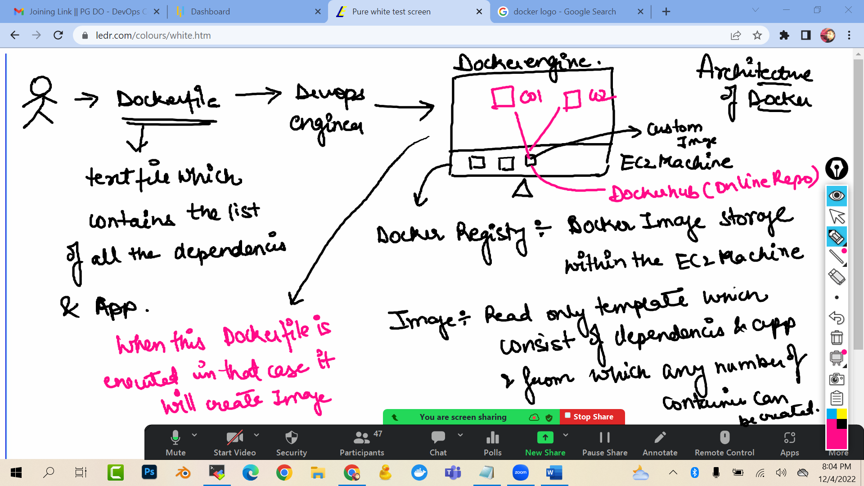

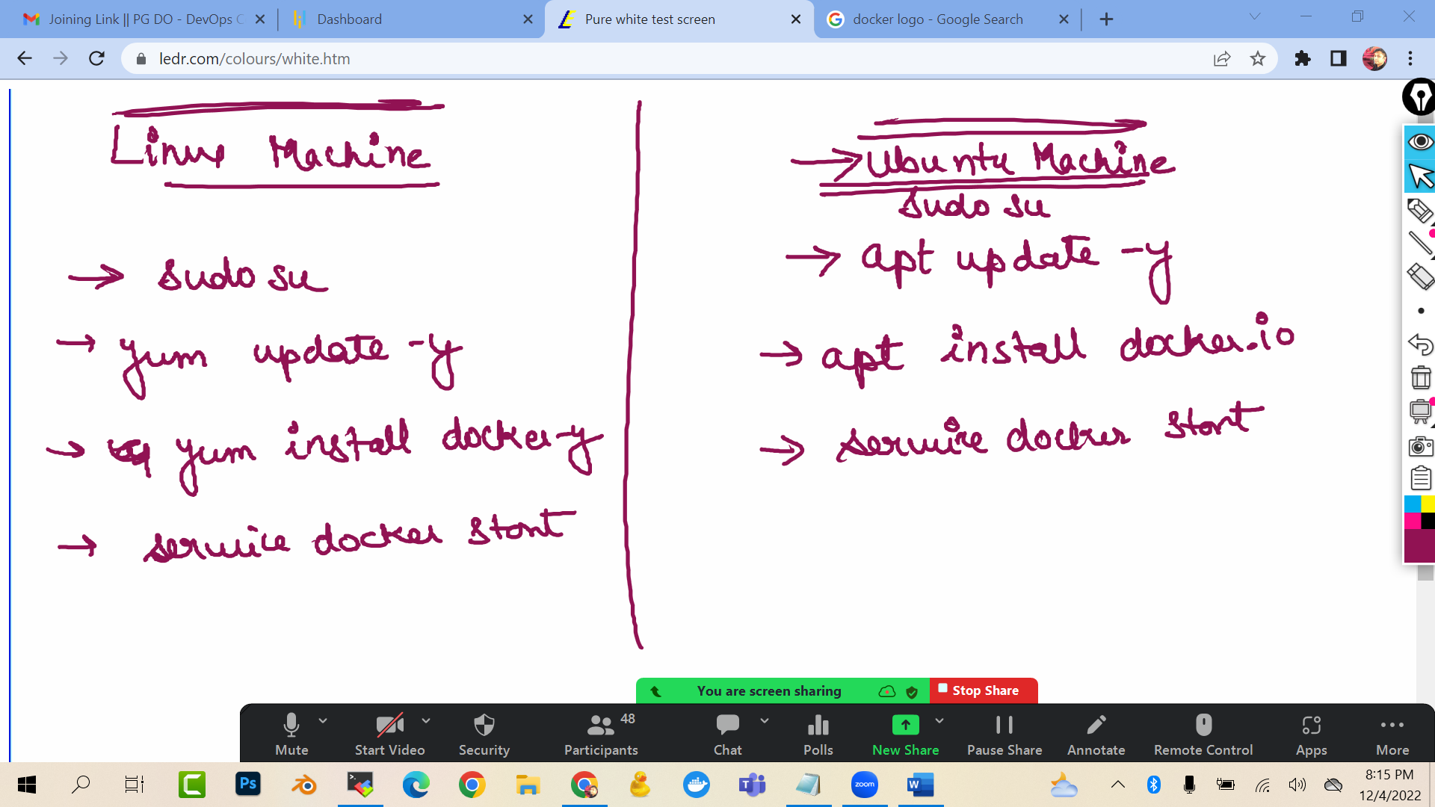

Launch a ubuntu ec2 machine
sudo su
apt update -y
apt install docker.io -y
docker --version
service docker start
service docker status

To check the images (read only template) in the docker registry (in ec2 machine)
docker images

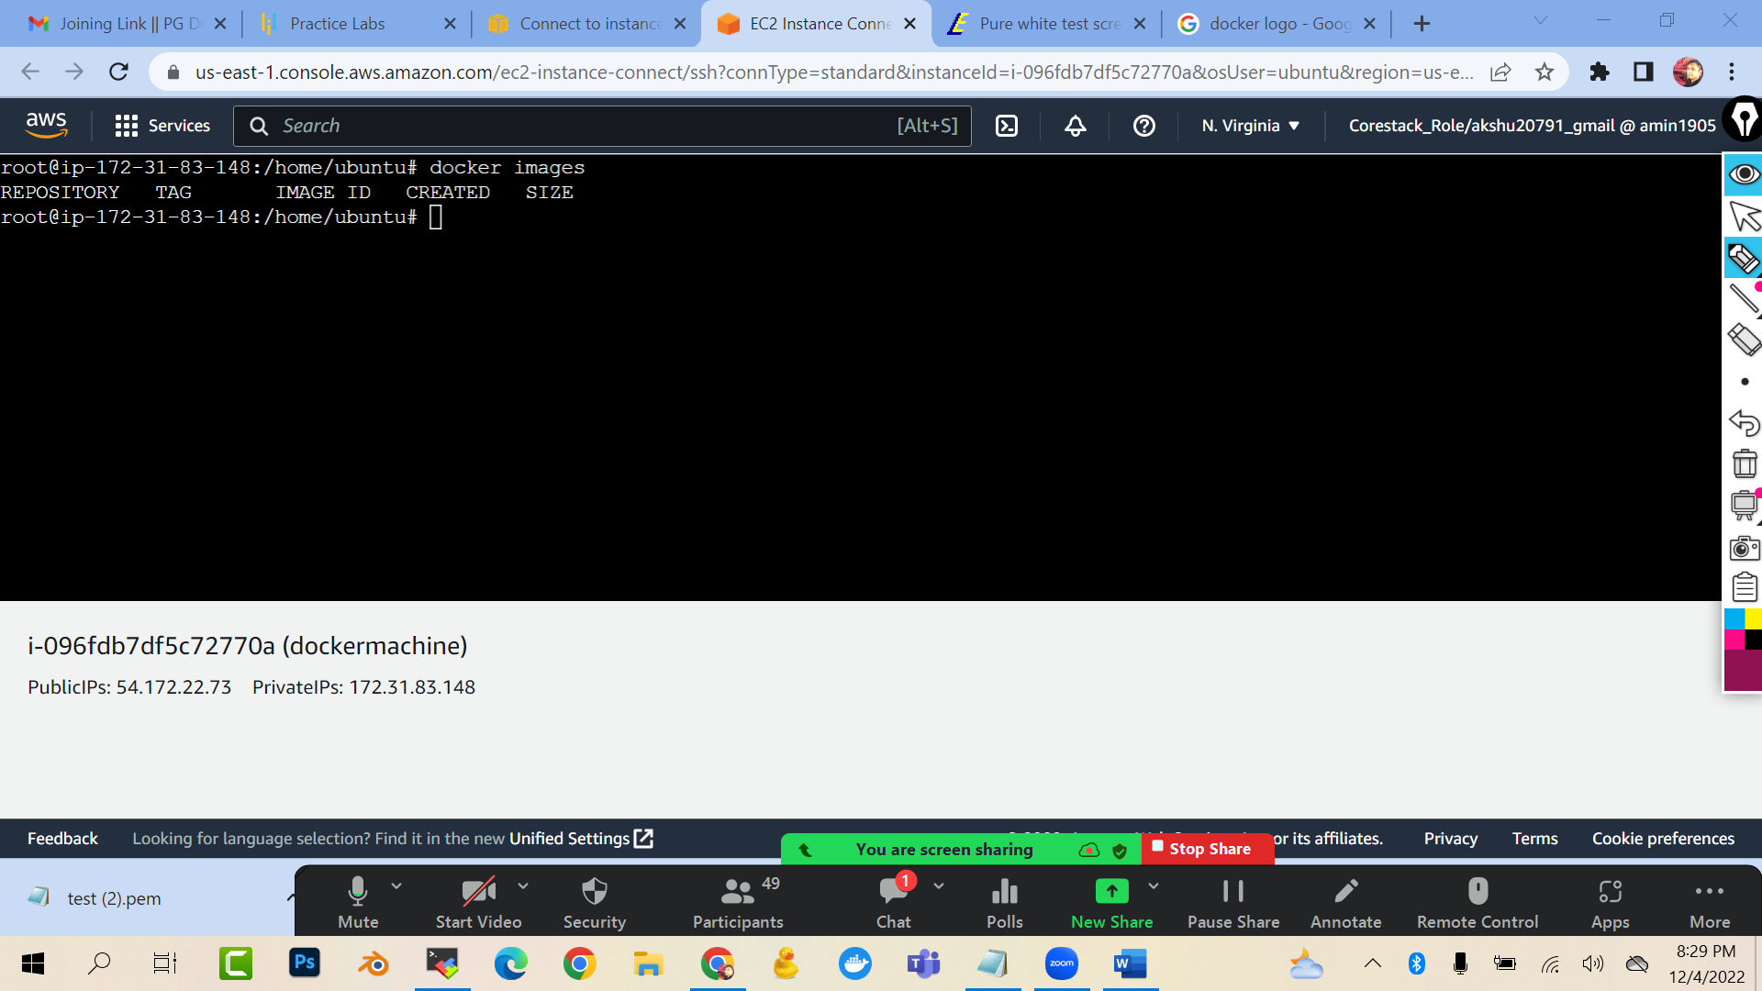

Create account on dockerhub

https://hub.docker.com/_/redis

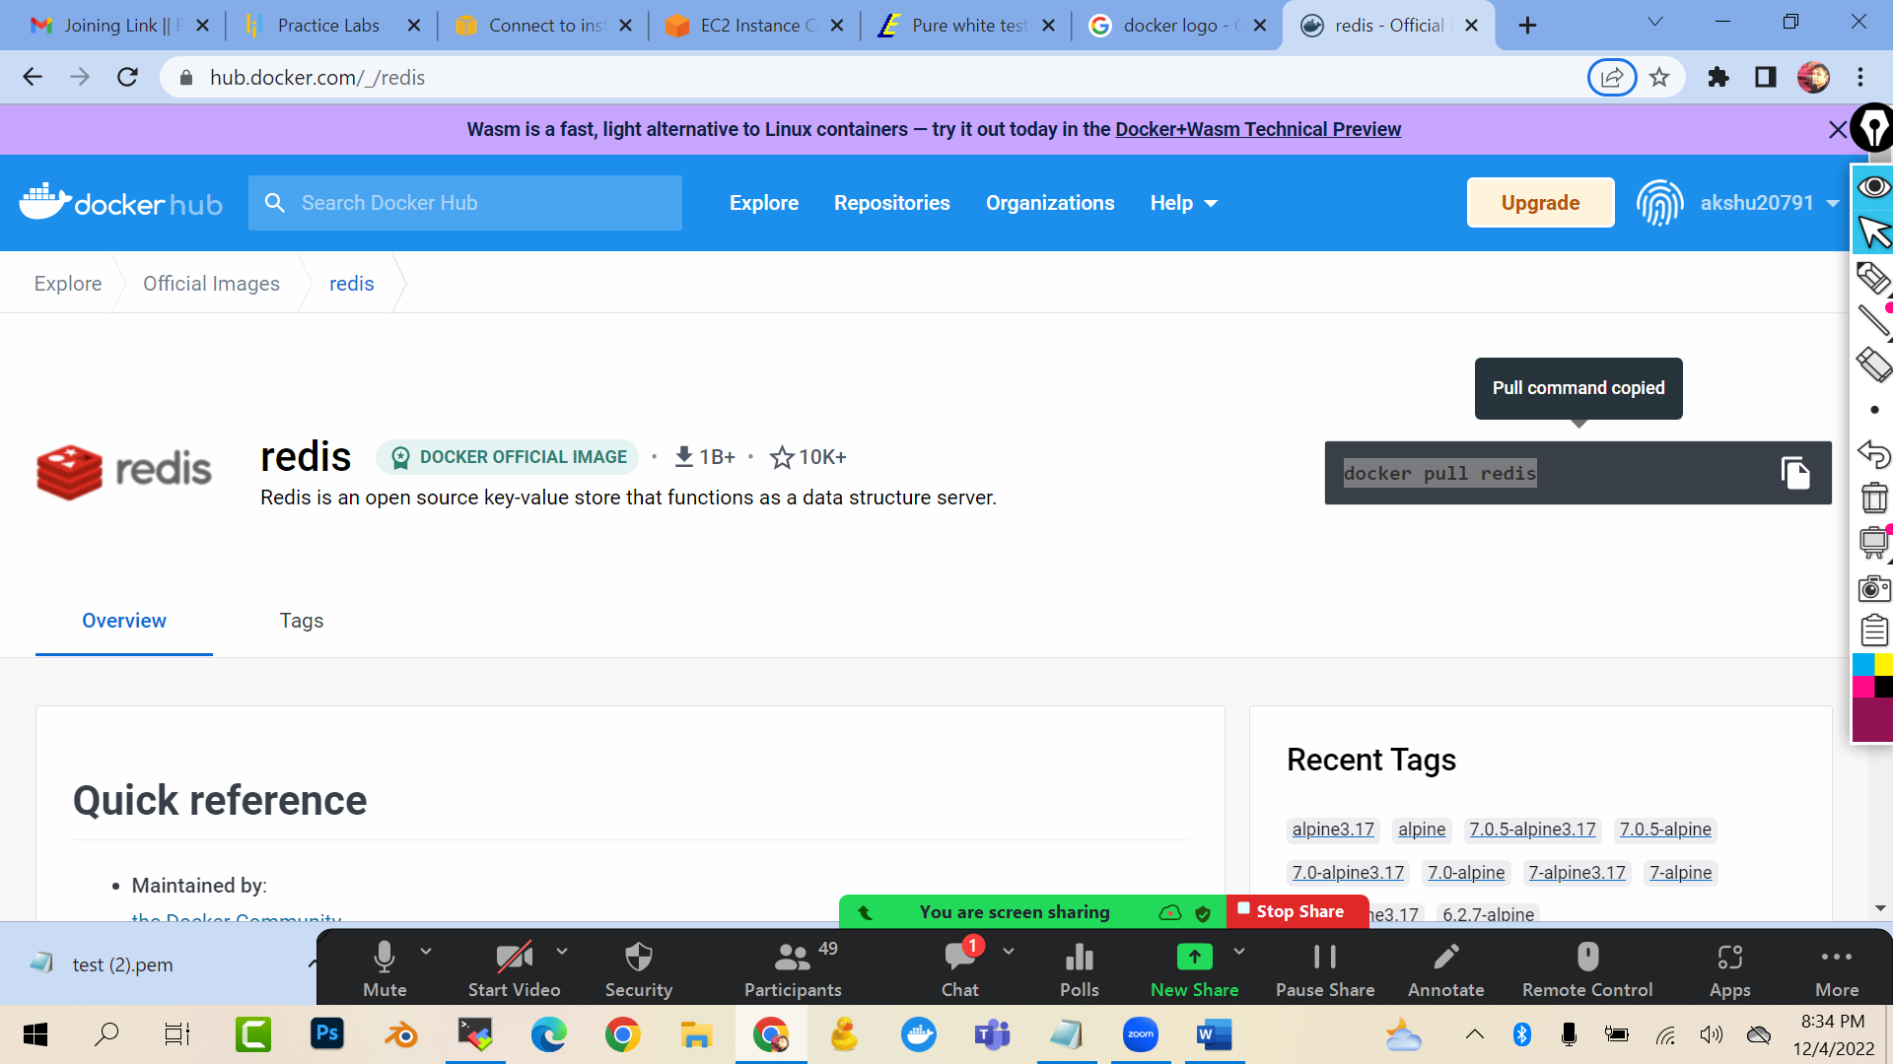

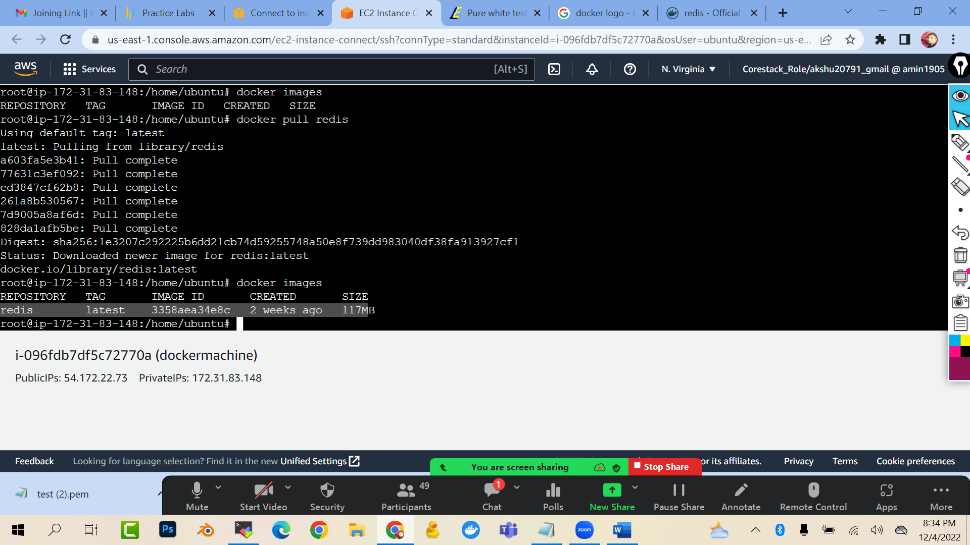

docker pull redis
docker images

### RIGHT NOW WE PULLED THE LATEST VERSION…BUT LETS SAY I DEVELOPER WANTS TO PULL THE SPECIFIC VERSION OF THE REDIS
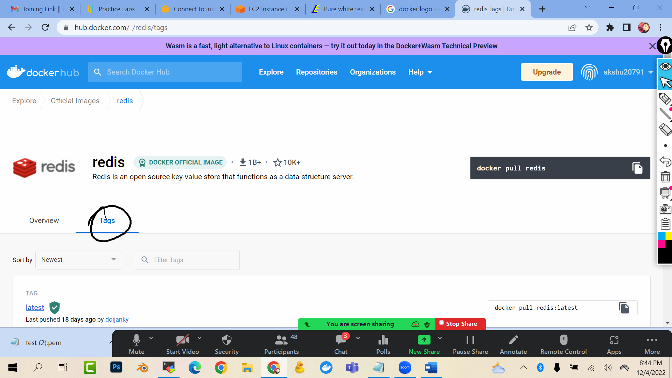

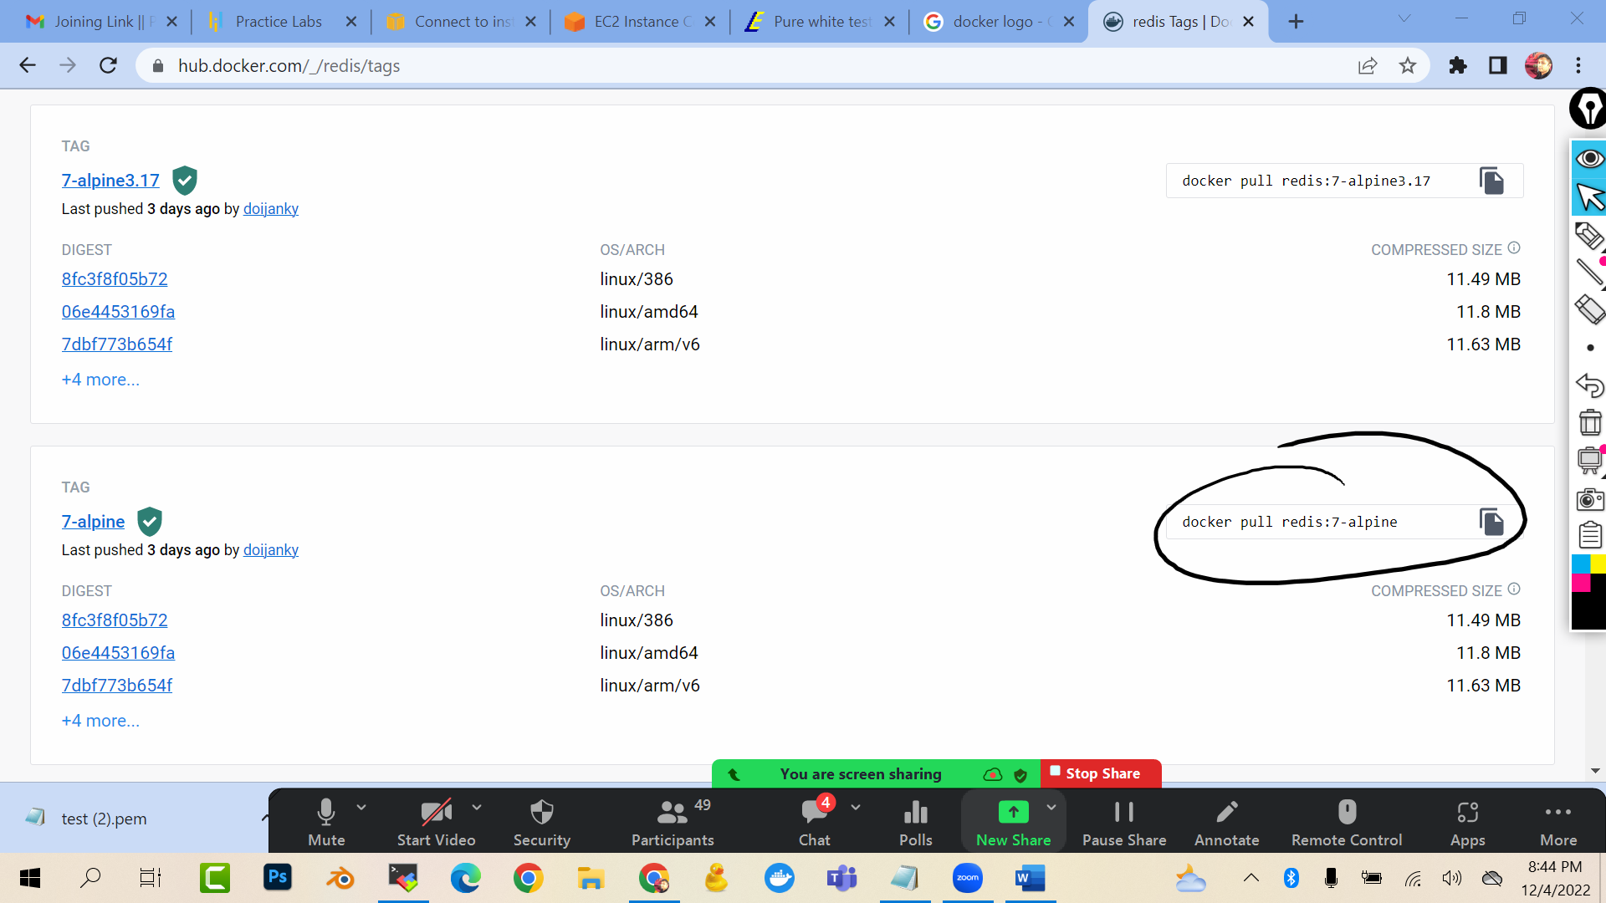

docker pull redis:7-alpine

docker images


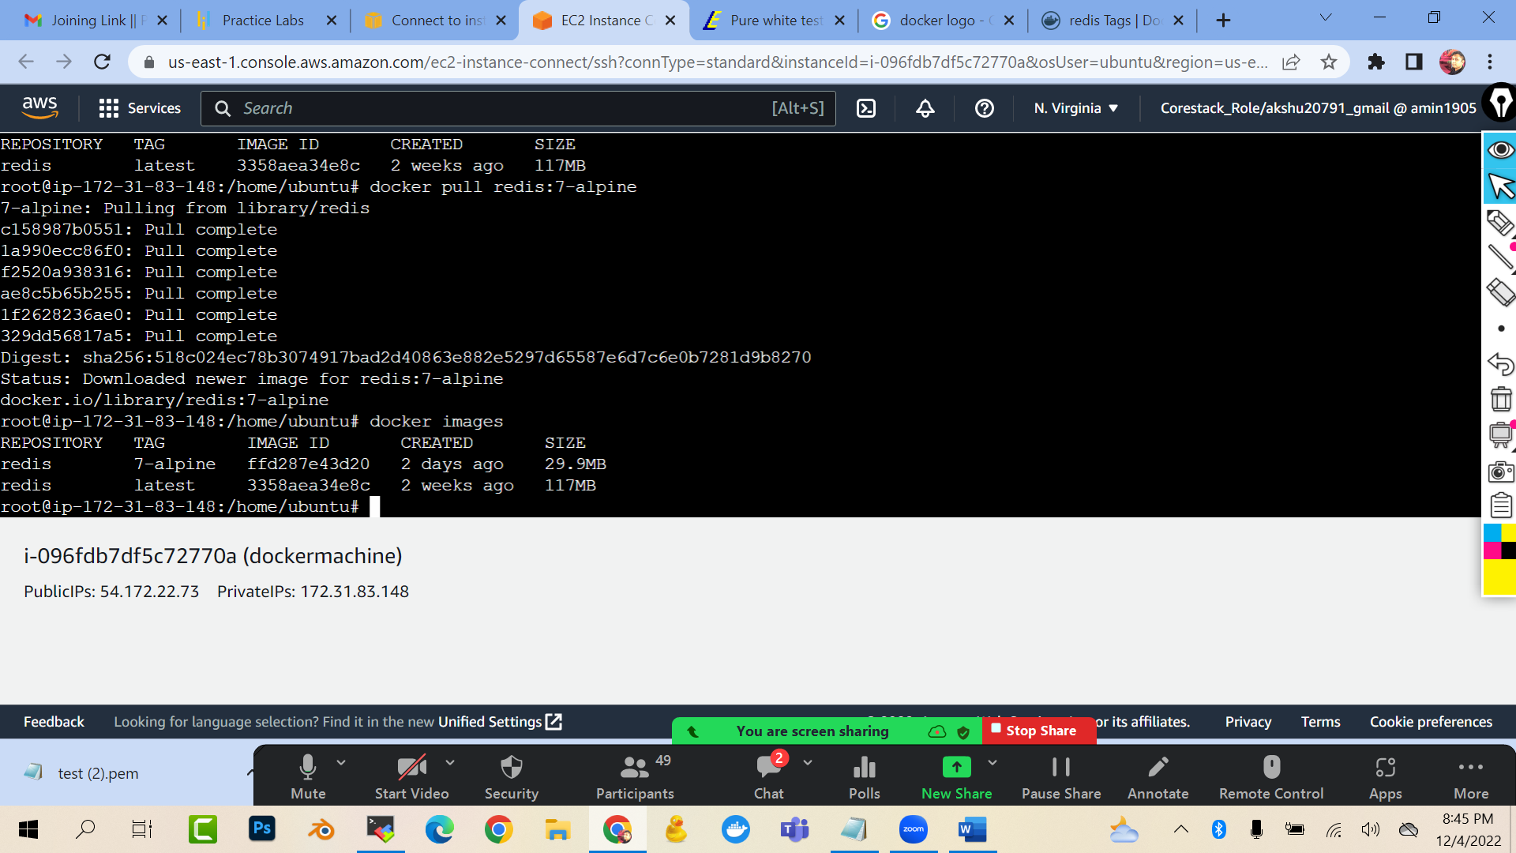
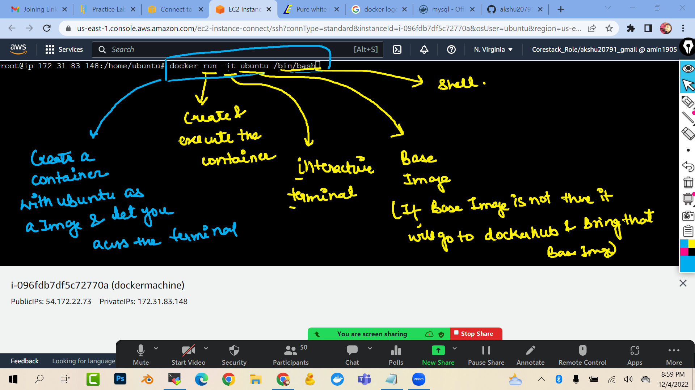

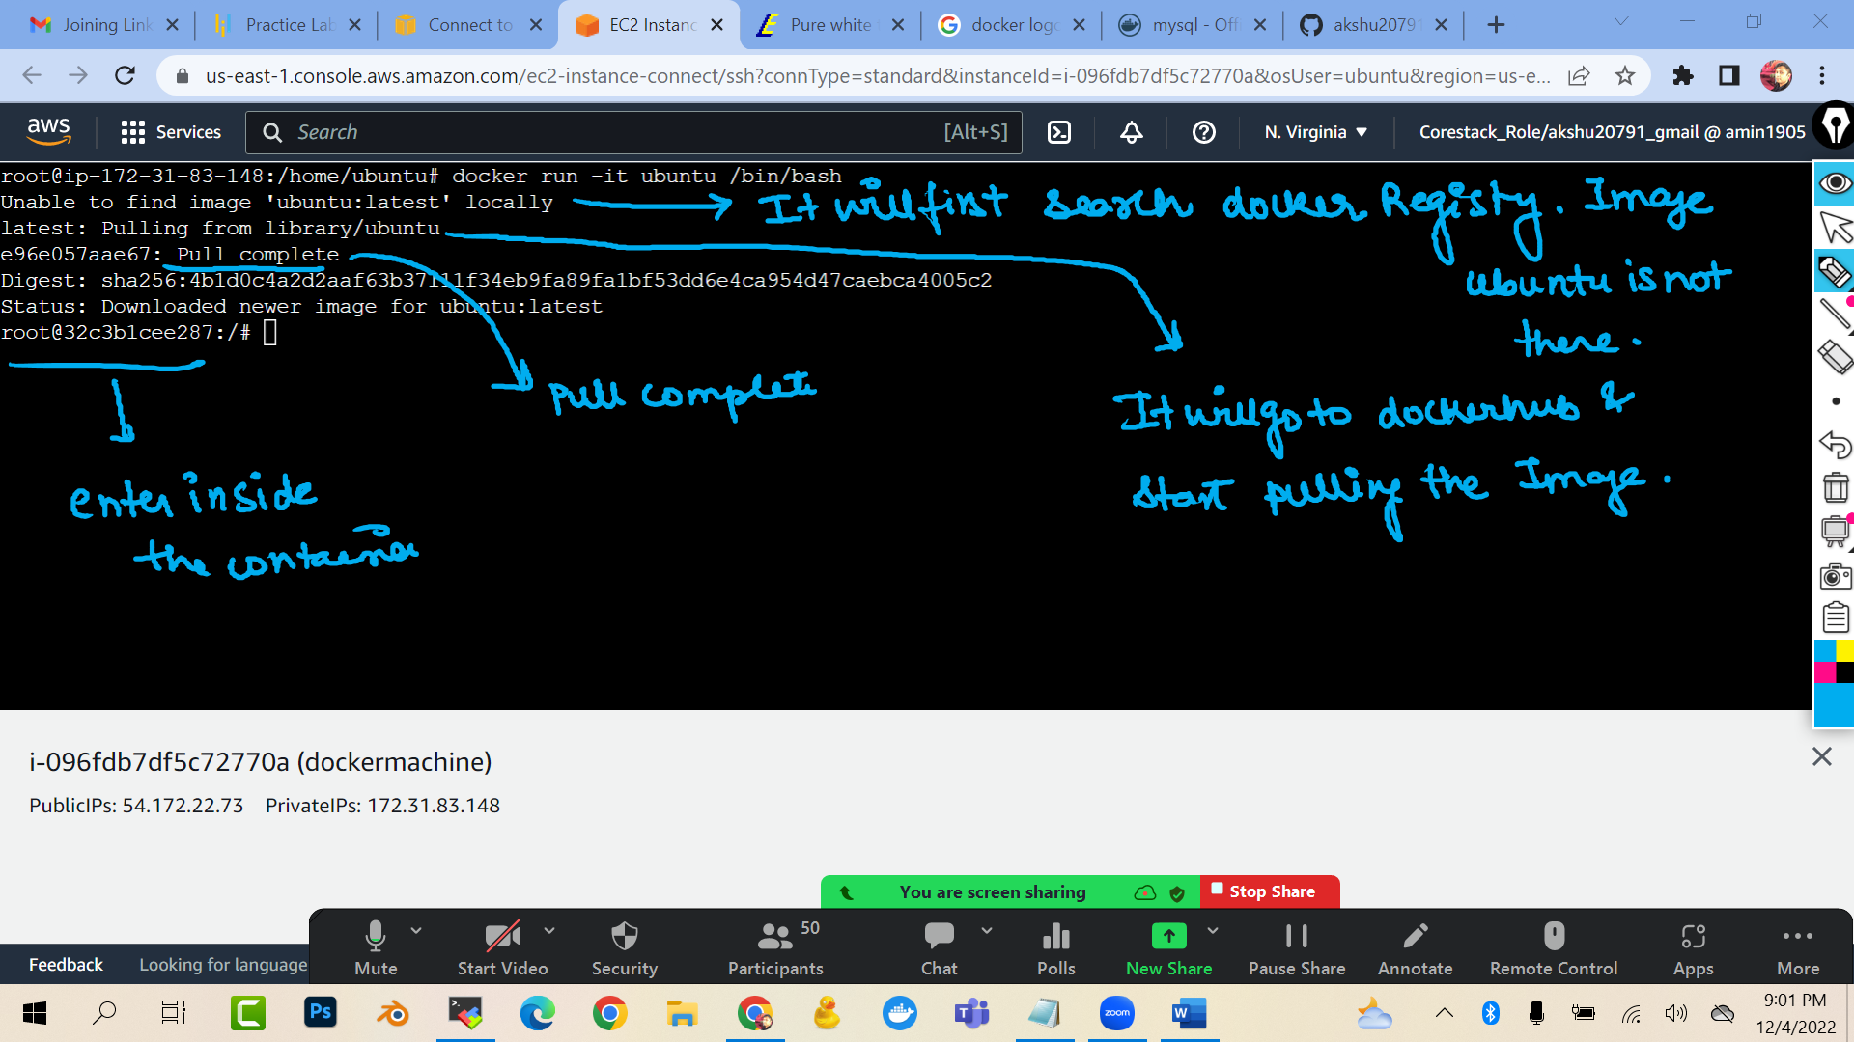

docker run -it ubuntu /bin/bash
(you will see that you have entered inside the container)

touch file1 file2 file3

ls
exit
ls
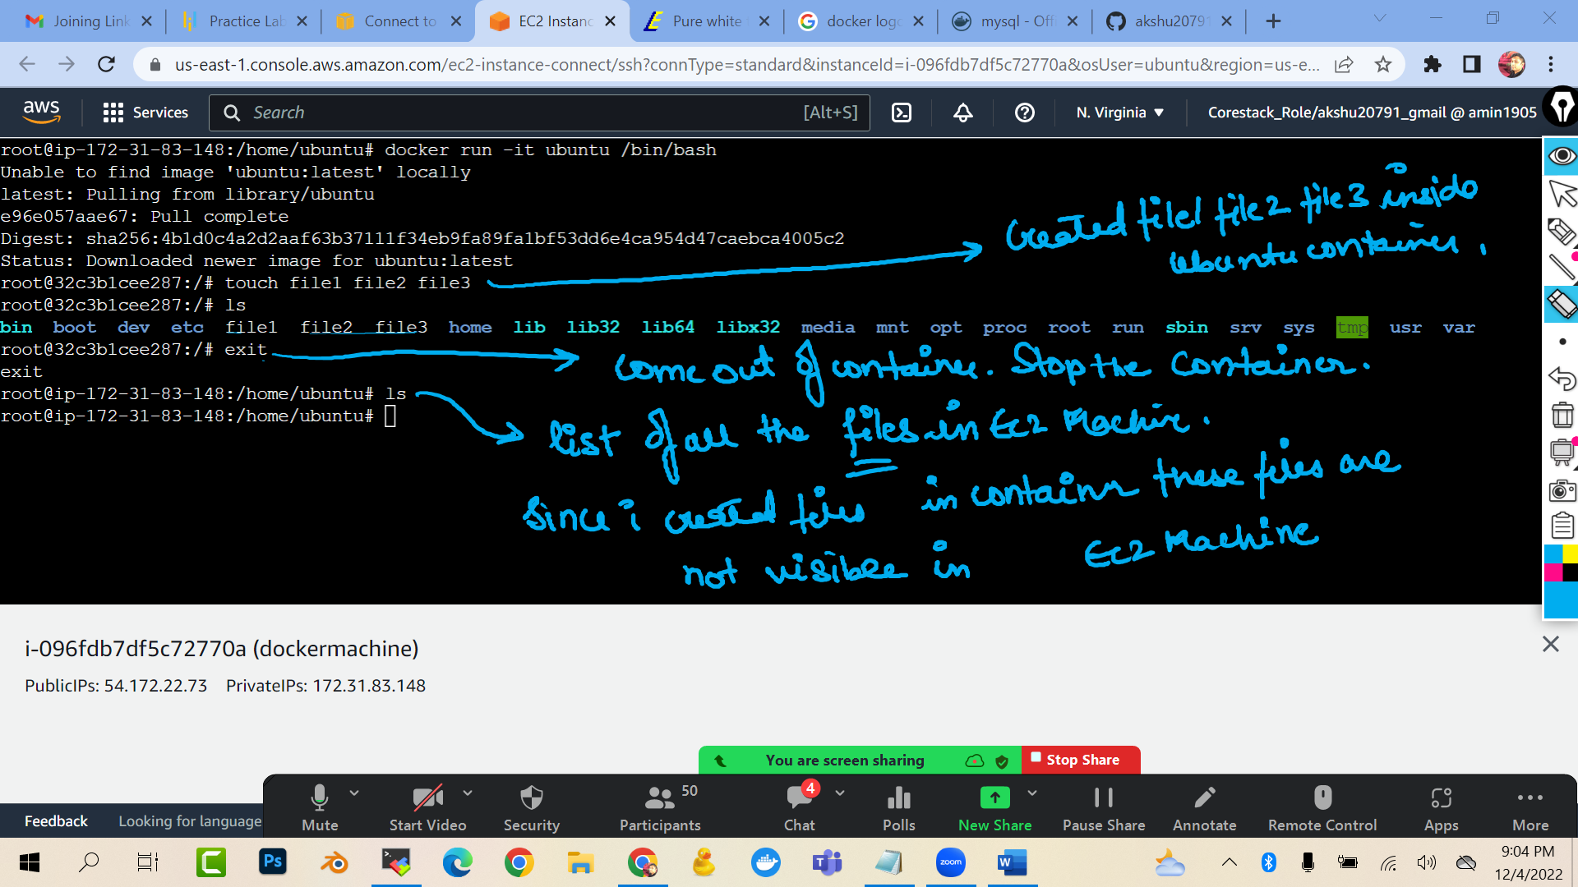

#### HOW TO LIST AND CHECK ALL THE CONTAINER ###############

docker ps -a
(ps: process)
(-a : all)
(it will list all the container for me)
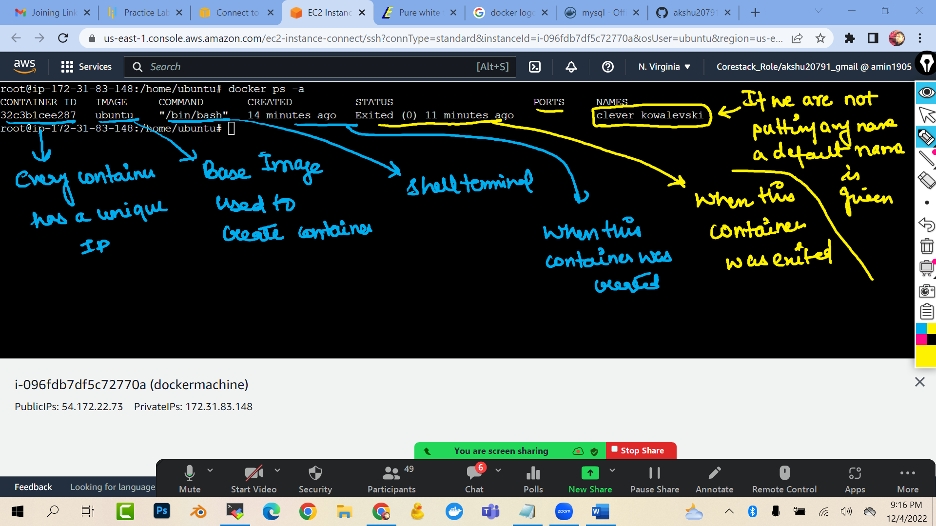

docker ps
(it will list only the running container)

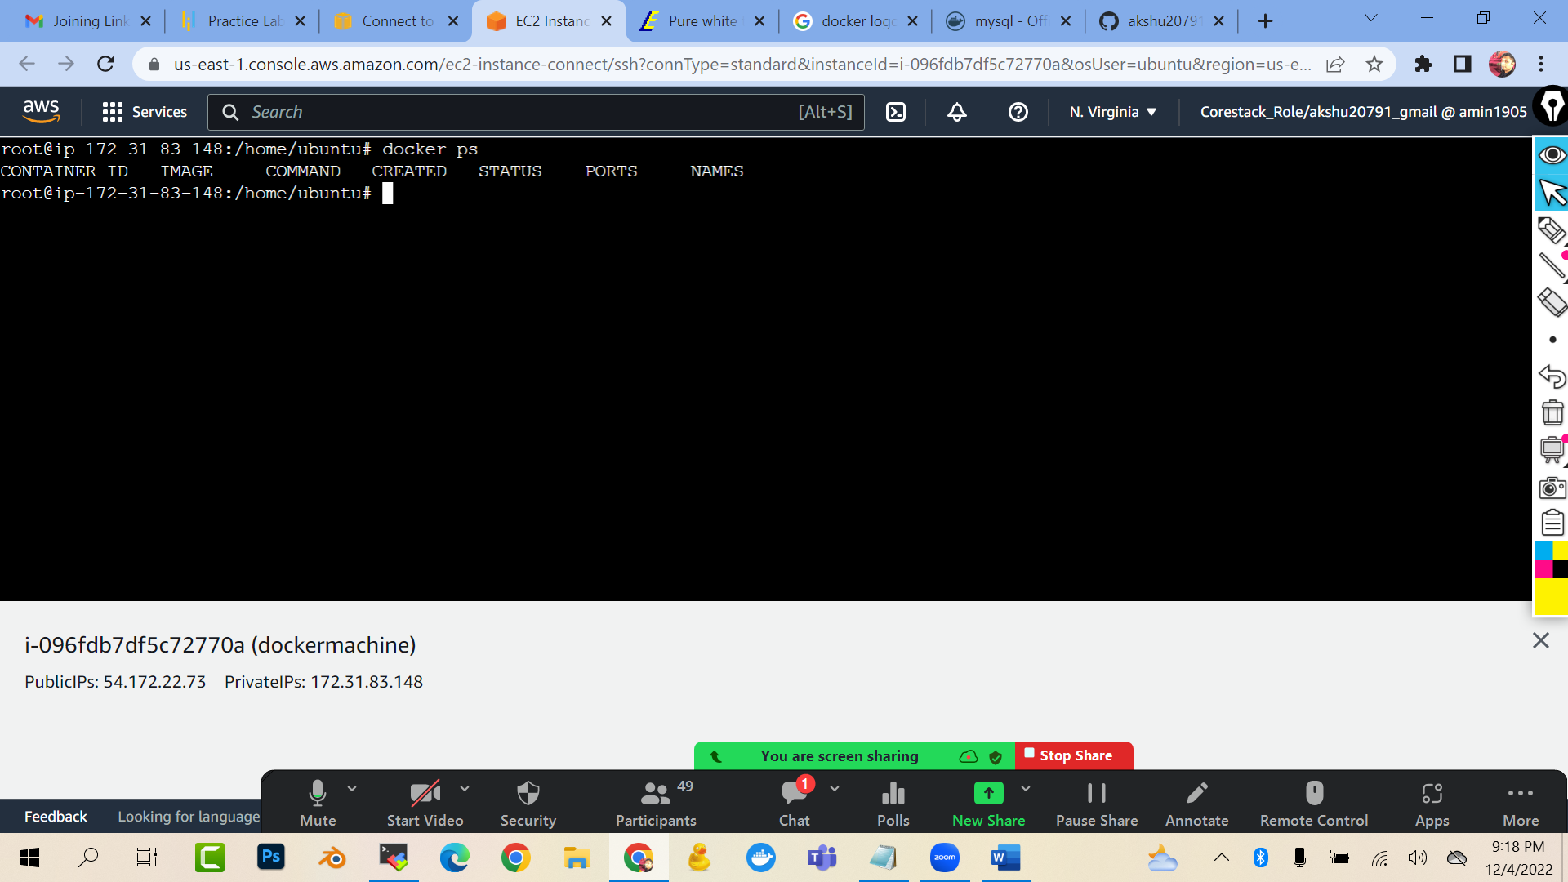
###HOW CAN I START THE CONTAINER AND GET INSIDE THE CONTAINER ###############

docker start <<name or id of your container>>
docker attach <<name or id of your container>>
(start : this command will start your container …attach : you will enter inside the container)
(you cannot attach to the stopped container)
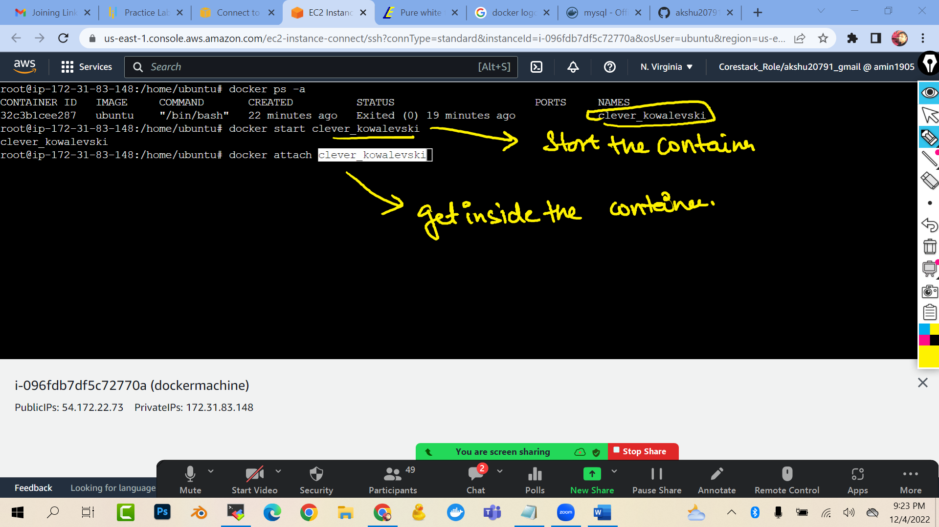

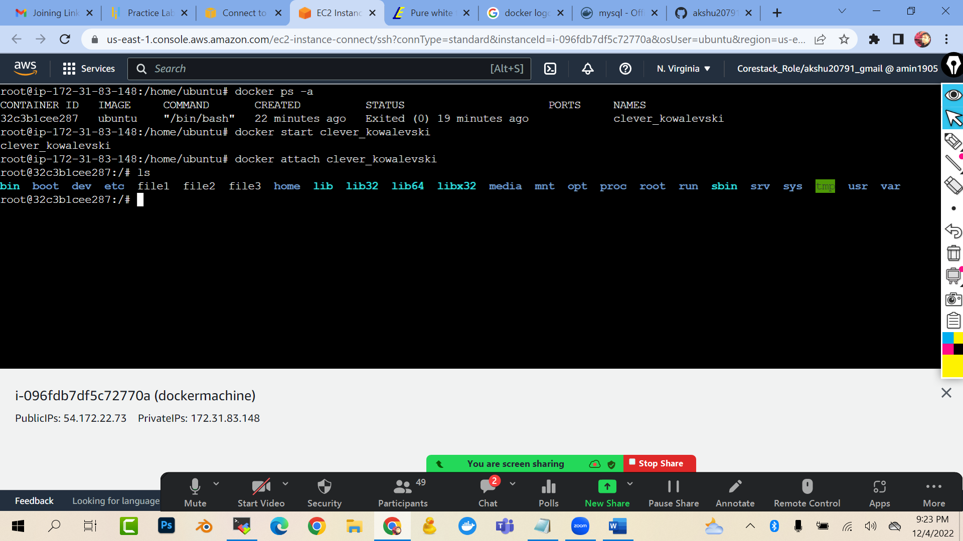

## DOCKER CONTAINER WITH SOME CUSTOM NAMES ######

docker run -it --name c01 ubuntu /bin/bash
(create a container with the name c01 and ubuntu as base image)
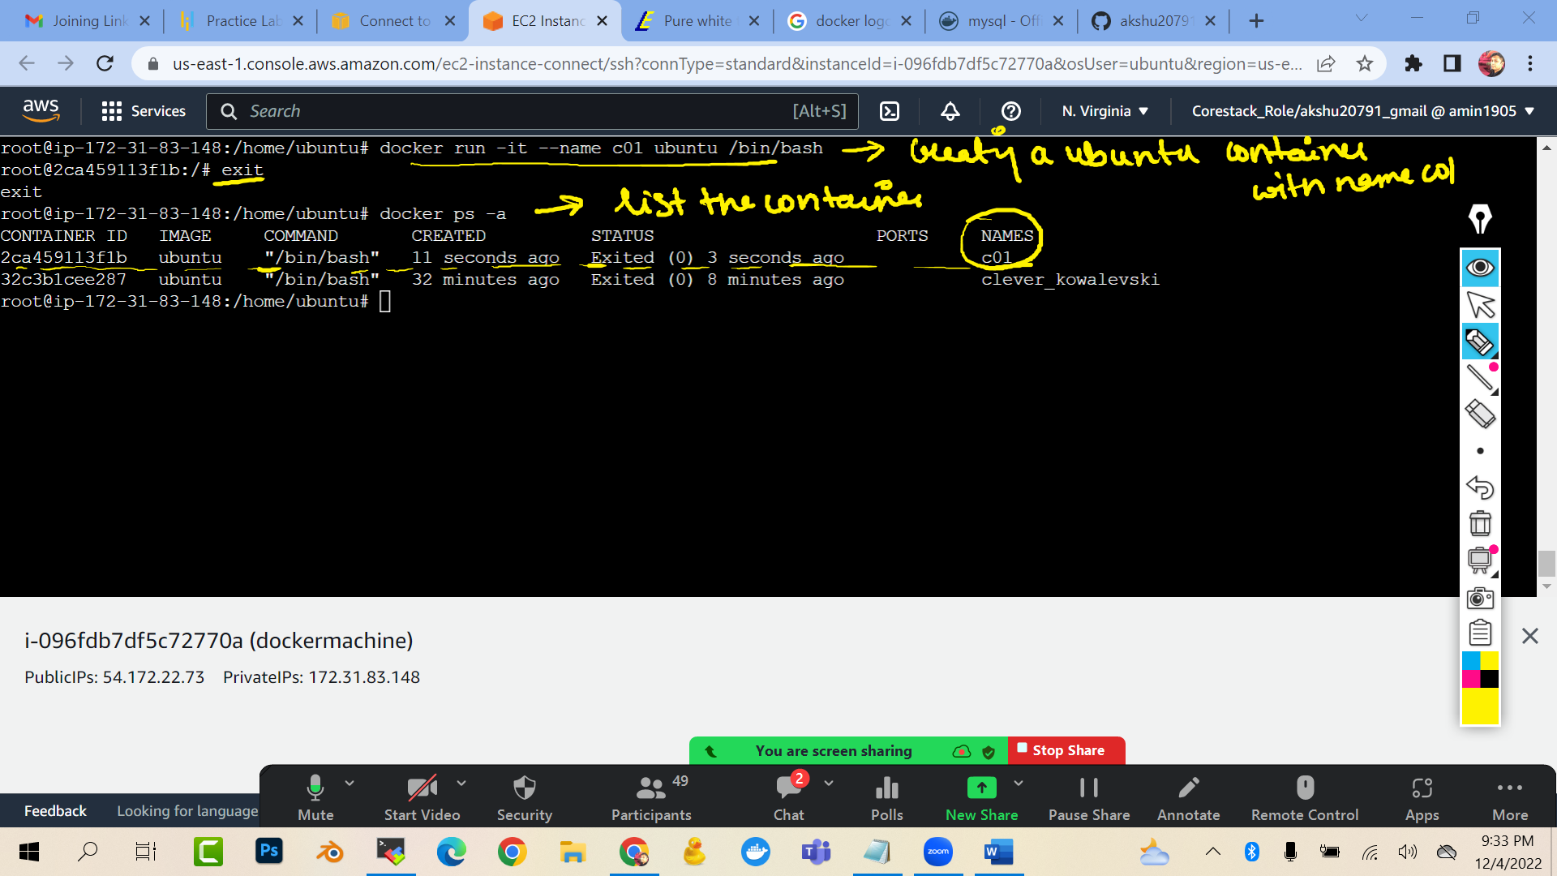

#####HOW TO COME OUT OF CONTAINER WITHOUT STOPPING (WITHOUT USING THE EXIT COMMAND)####

docker run -it --name c02 ubuntu /bin/bash
you will enter inside the container

now rather then typing exit
press ctrl p and ctrl q
(save the process and quit the container)

###delete the container:
docker rm <<containername>>

##delete the image
You cannot delete the image which is been used currently by a container
docker rmi <<imagename>>
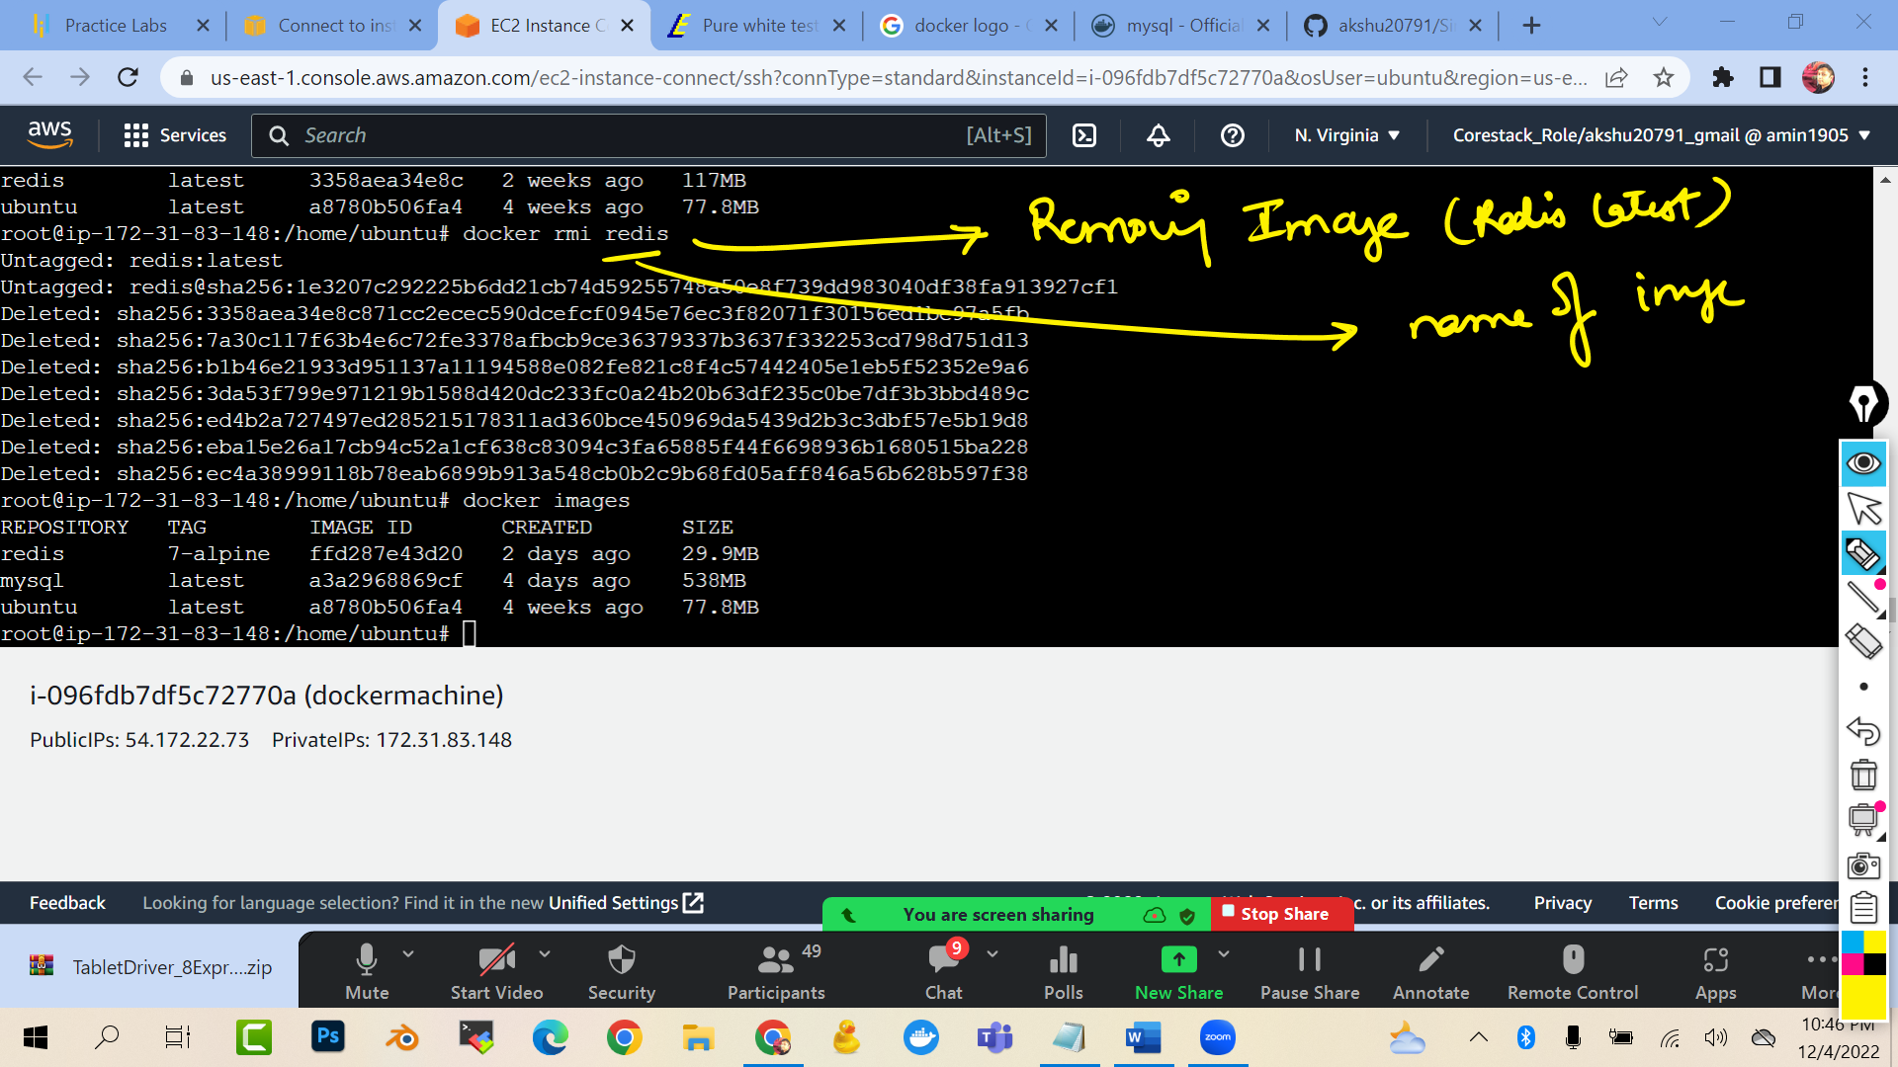

#### HOW WE CAN CREATE A CUSTOM IMAGE FROM A CONTAINER ##############
Lets say you have a container with some files in that. Now you want to create a replica of that container ,…how we will do it?
docker run -it --name c04 ubuntu /bin/bash
touch file1 file2 file3 file4 file5
ls
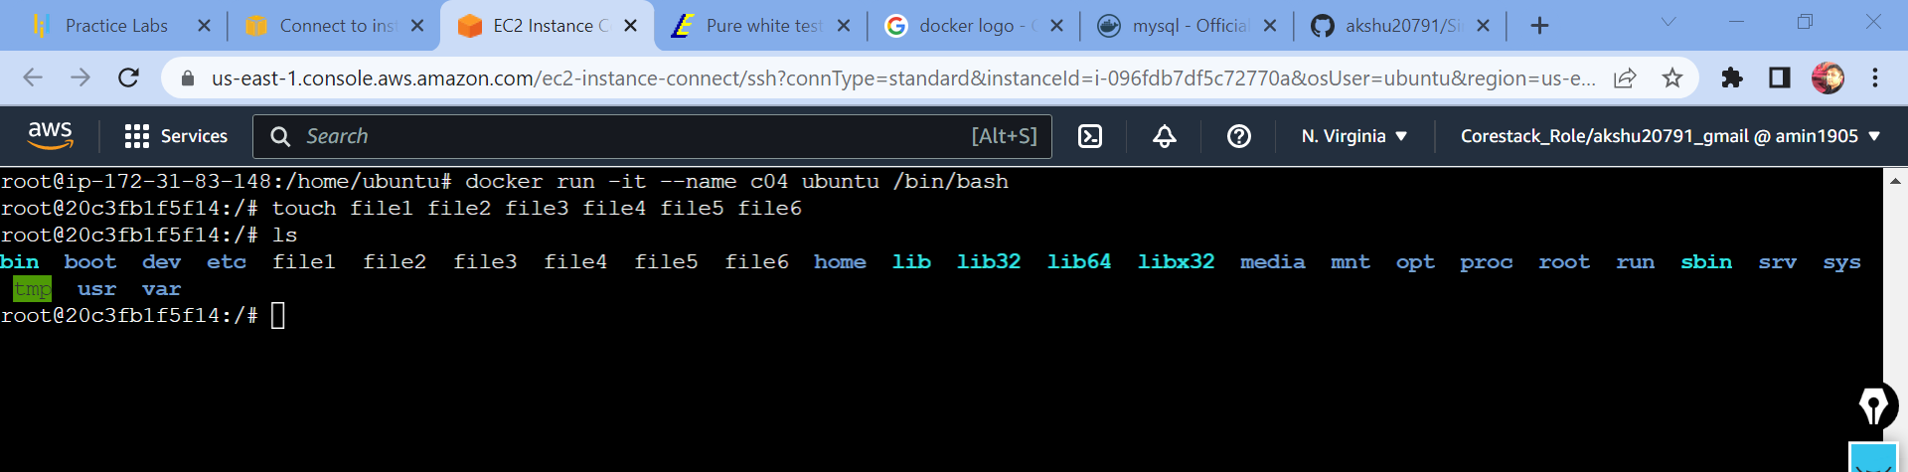


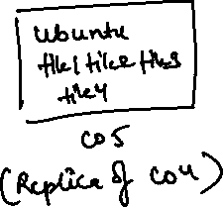





Now we need to create a custom image from the container c04
docker commit c04 customimg
(this command will create a custom image with name customimg which is the read only template (image) of the container c04)
docker images
(you will see that a image with name customimg is there)
docker run -it --name c05 customimg /bin/bash
(now we are creating a container c05 from the customimg as the base image)
ls (list)

you will see all the files …which we created in c04

